EXPT NO: 4 | TRANSFER LEARNING USING PRE-TRAINED VISION MODELS FOR IMAGE RECOGNITION
DATE:

PRE-LAB QUESTIONS (PROVIDE BRIEF ANSWERS TO THE FOLLOWING QUESTIONS)

1.What is transfer learning in deep learning?
Transfer learning is a technique where a model trained on a large dataset is reused for a new, related task. This saves time and computational resources.

2. What are the advantages of using pre-trained models over training from scratch?
- Requires less training time and data.
- Reduces computational cost.
- Often provides better accuracy.
- Uses features already learned from large datasets.

3. What is the role of fine-tuning in transfer learning?
Fine-tuning involves training some or all layers of a pre-trained model on a new dataset so that it adapts better to the specific task.

4. Name any three popular pre-trained computer vision models.
- ResNet
- VGGNet
- MobileNet

5. What is the purpose of Hugging Face and how is it useful in deep learning?
Hugging Face is a platform that provides pre-trained AI models, datasets, and tools. It makes it easier to find, use, fine-tune, and deploy models for tasks such as image classification, NLP, and generative AI.
AIM
To implement transfer learning using pre-trained vision models for image recognition and evaluate their performance on real-world image datasets.

SOFTWARE REQUIREMENTS
- Python
- TensorFlow/Keras or PyTorch
- Google Colab
- Hugging Face Transformers
- Kaggle Dataset
- Matplotlib
- GitHub

OBJECTIVES
Students will be able to:
- Understand the concept of transfer learning.
- Apply pre-trained vision models for image recognition.
- Fine-tune models such as ResNet or AlexNet.
- Utilize Kaggle datasets and Hugging Face vision models.
- Compare transfer learning performance with custom CNN models.

PROCEDURE
PART A: DATASET PREPARATION
Perform the following tasks:
- Download an image dataset from Kaggle.
- Load and preprocess the images.
- Split the dataset into training, validation, and testing sets.

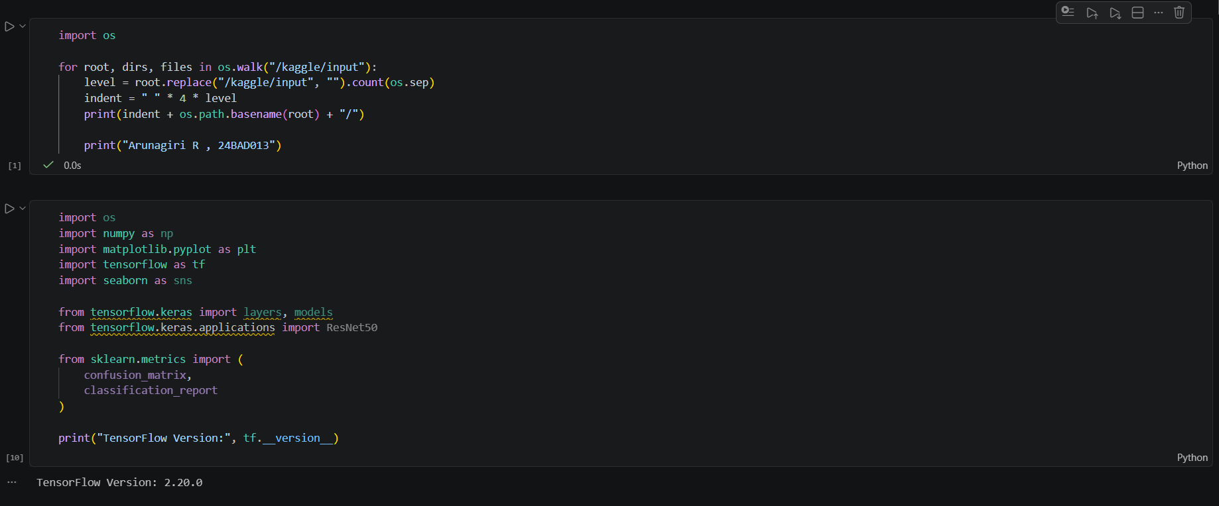

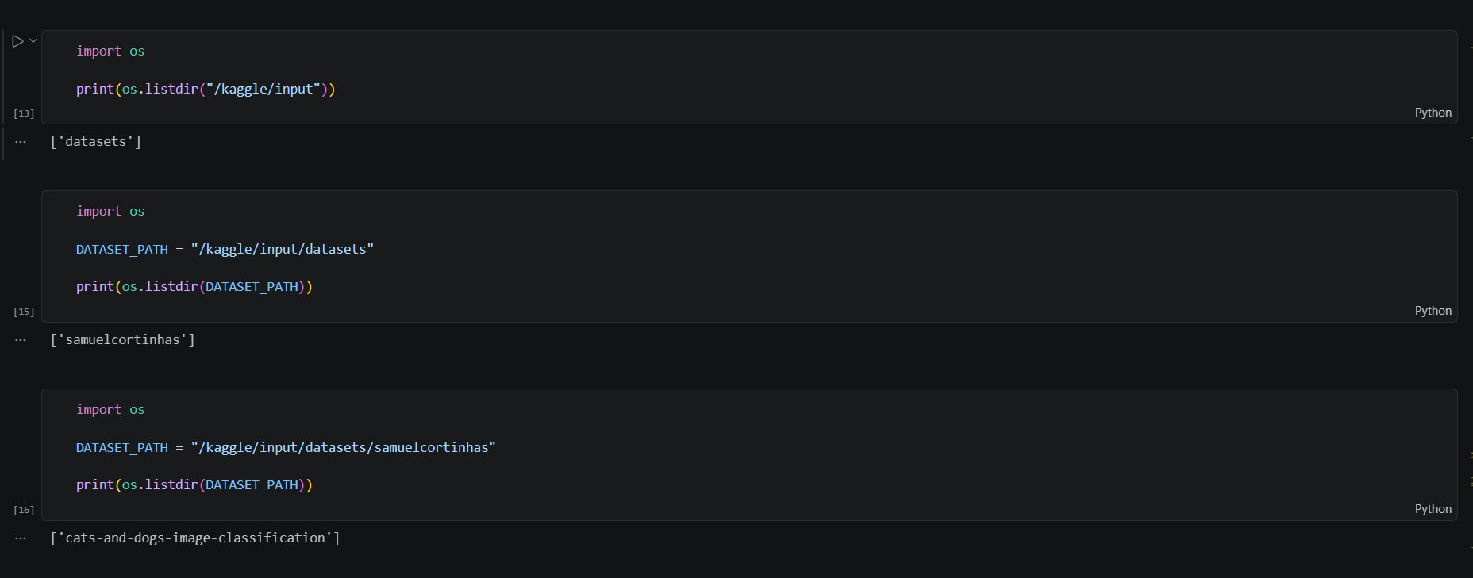

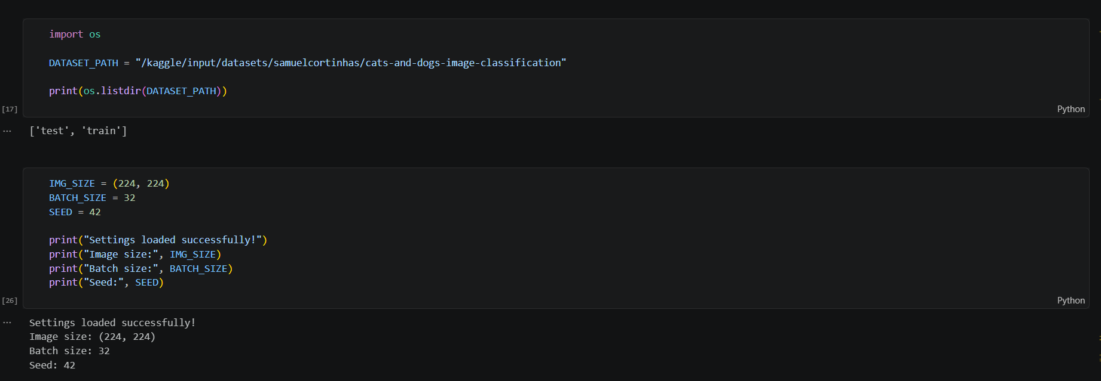

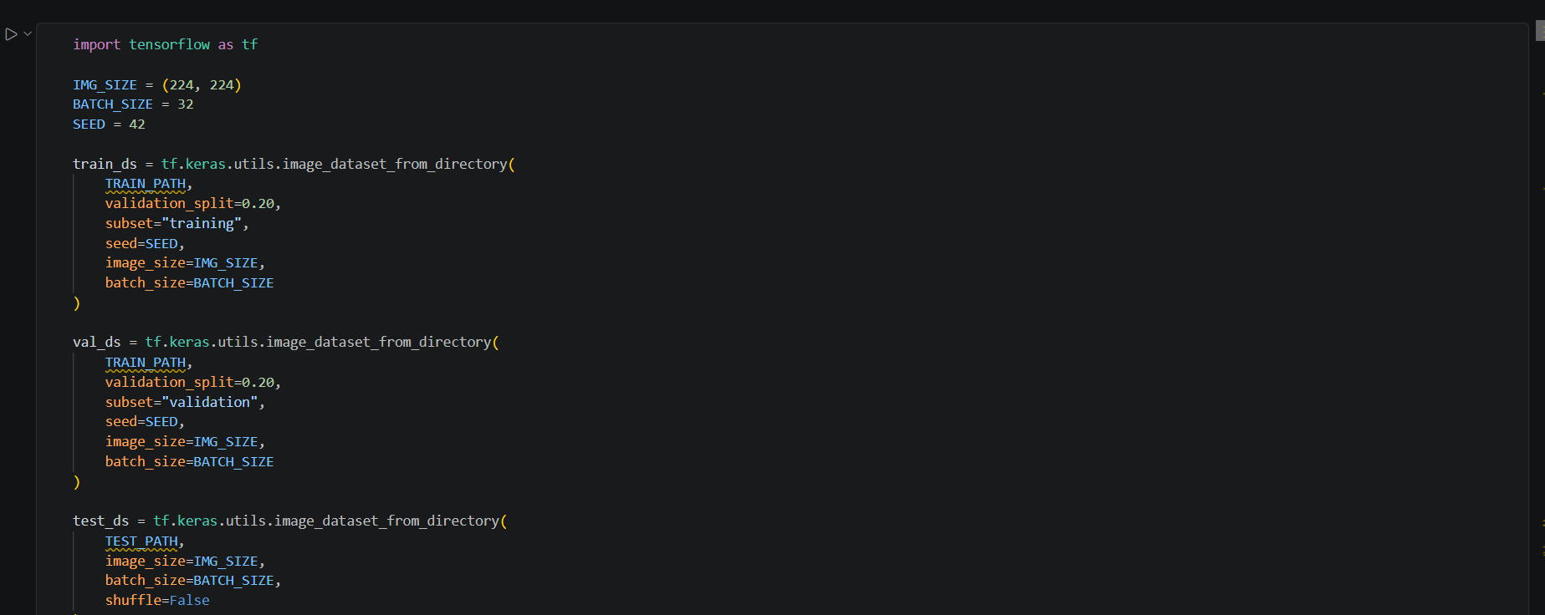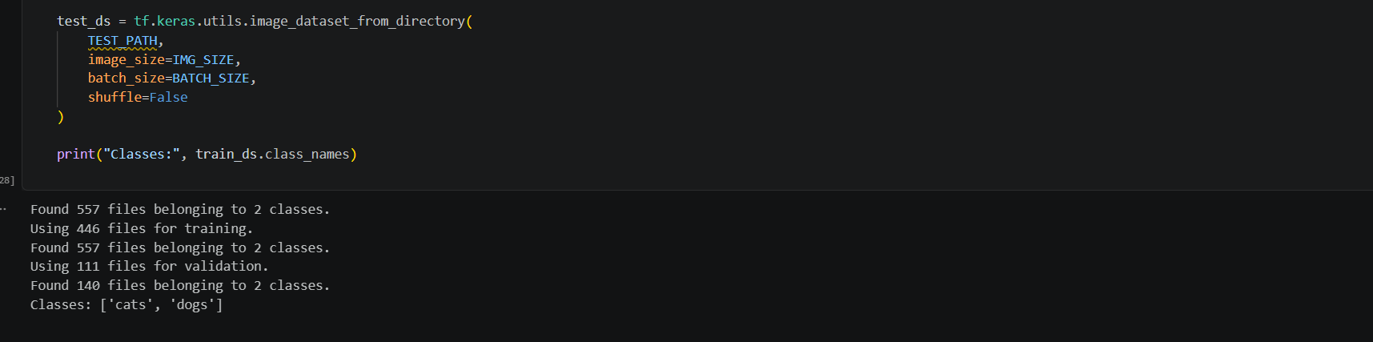

PART B: IMPLEMENTING TRANSFER LEARNING
Load a pre-trained model such as:
- ResNet-50
- AlexNet
Replace the final classification layer according to the dataset classes.
Freeze the feature extraction layers.
Compile the model.

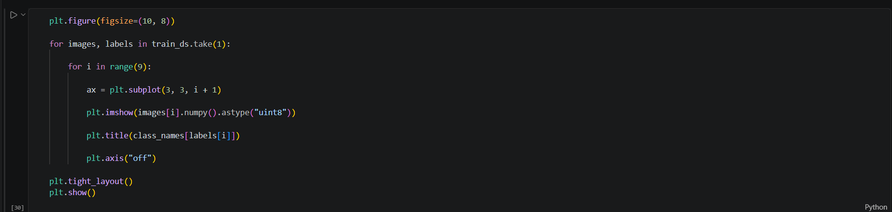

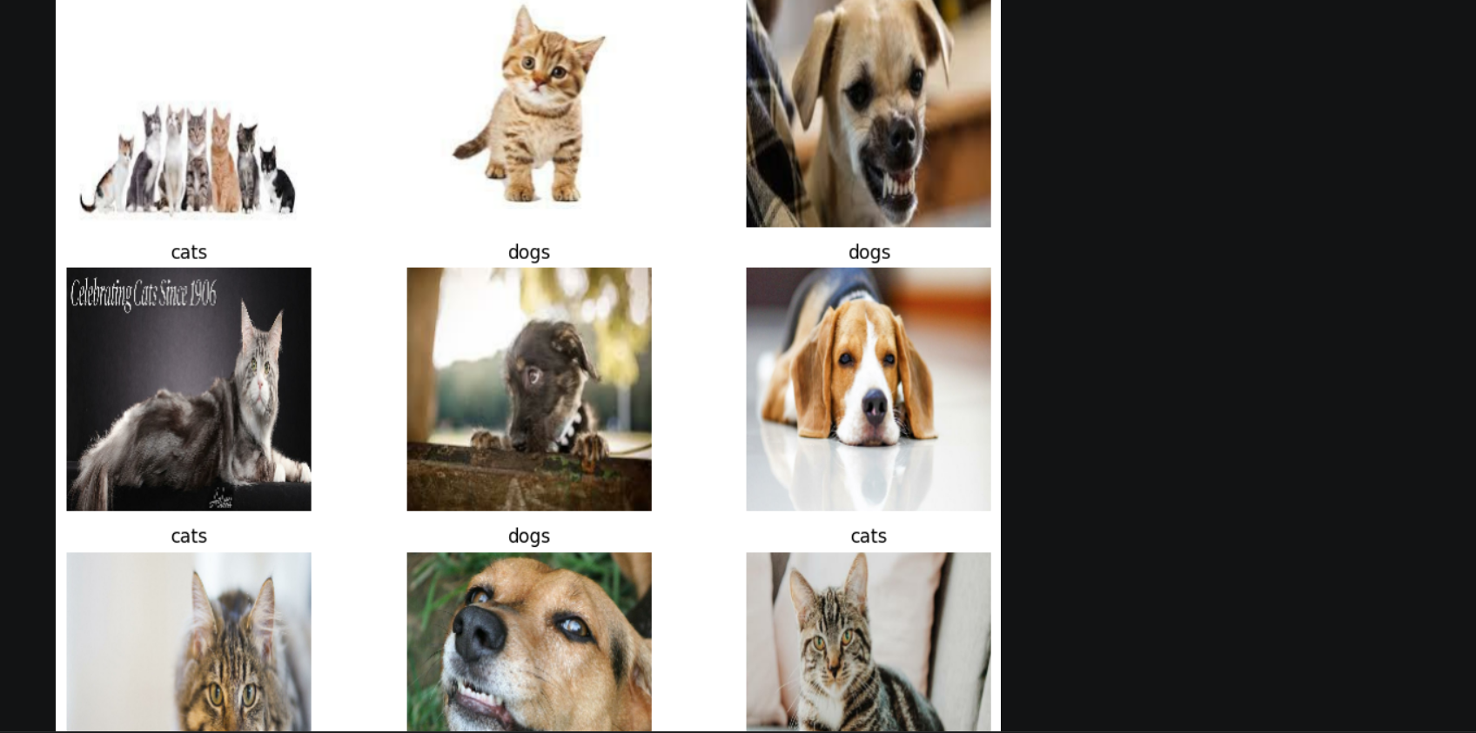

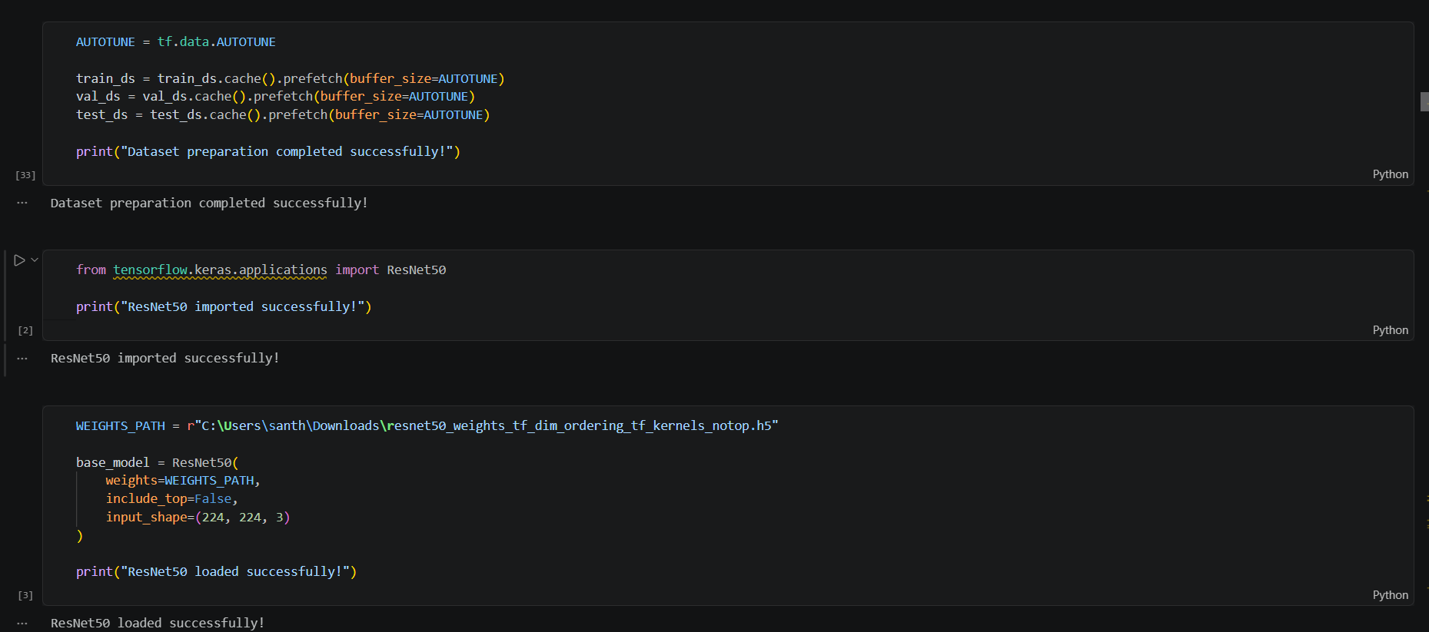

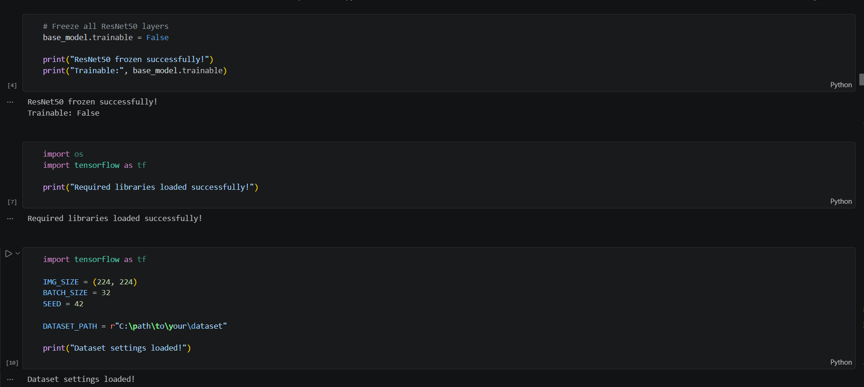

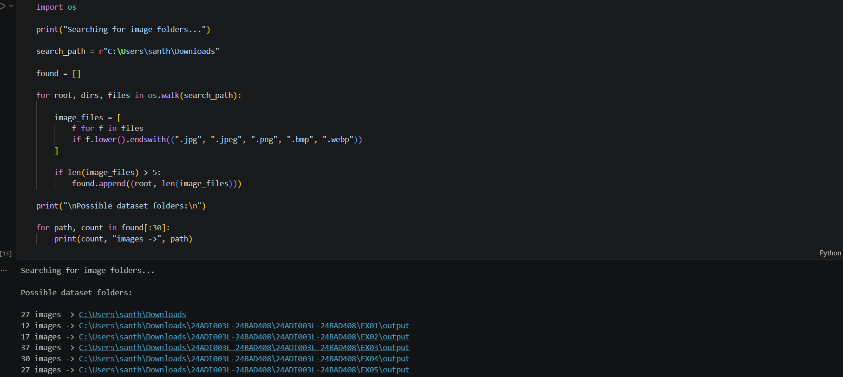

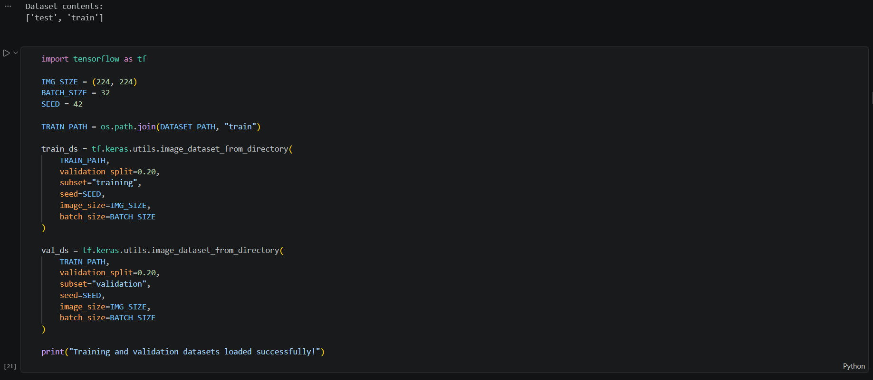

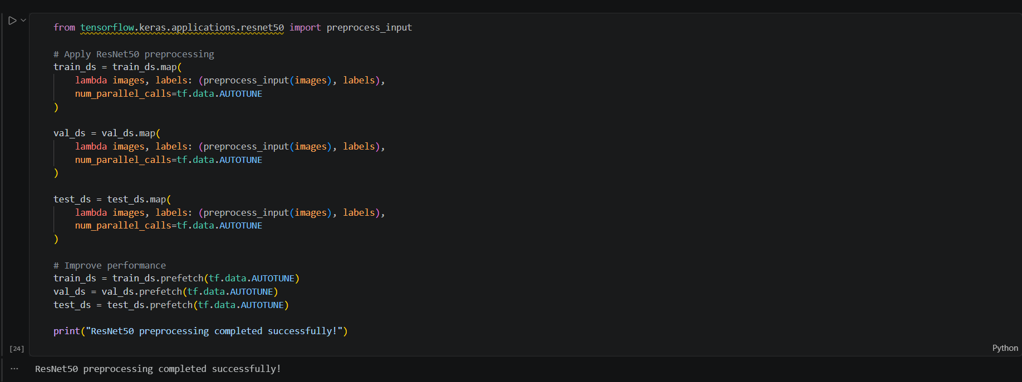

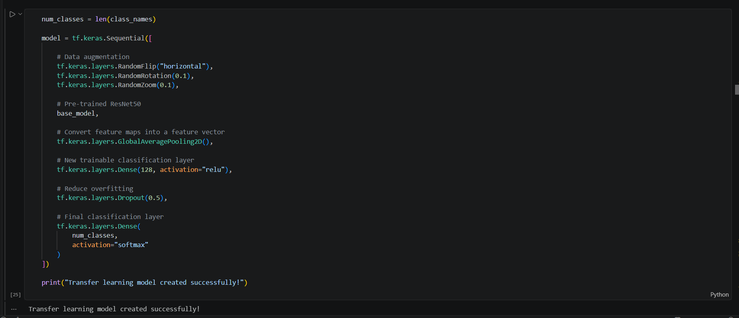

PART C: MODEL TRAINING AND PERFORMANCE EVALUATION
Train the transfer learning model.
Record:
- Training accuracy
- Validation accuracy
- Training loss
- Validation loss
- Test accuracy
Visualize:
- Accuracy vs Epoch
- Loss vs Epoch

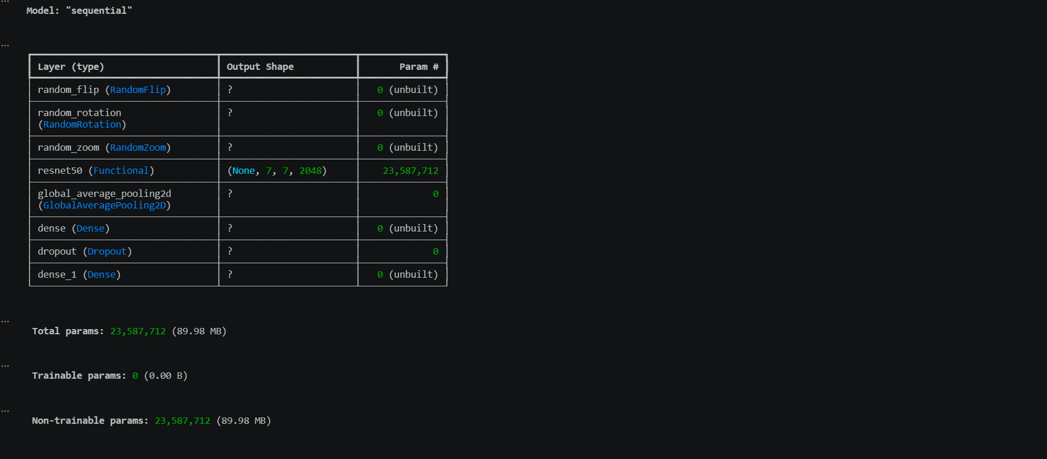

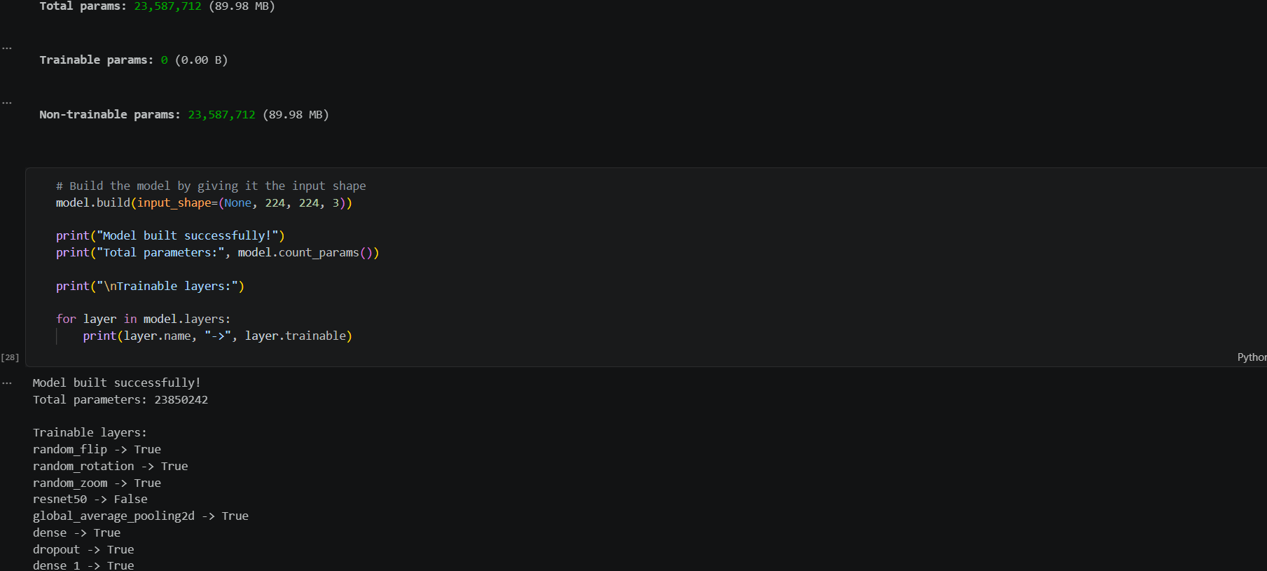

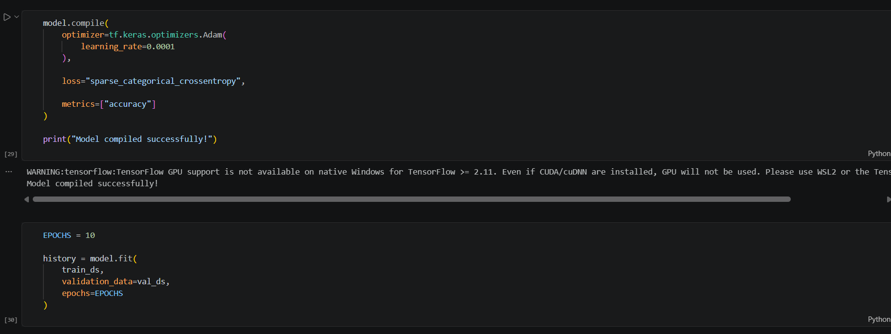

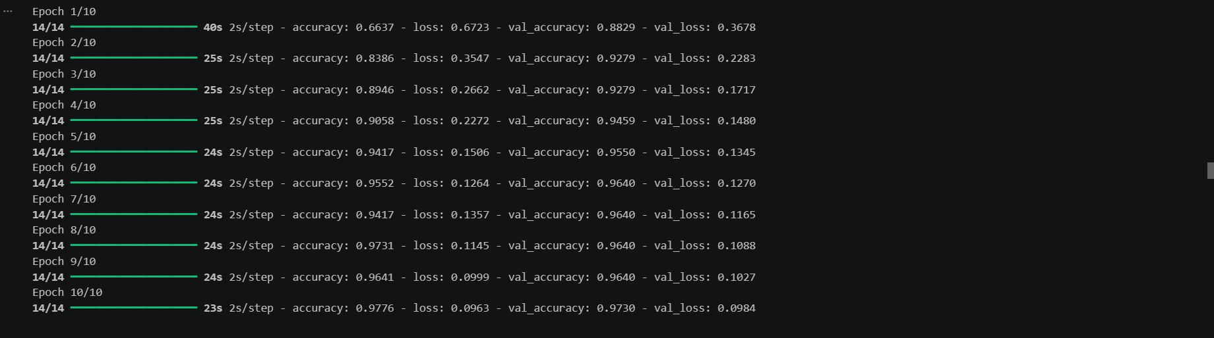
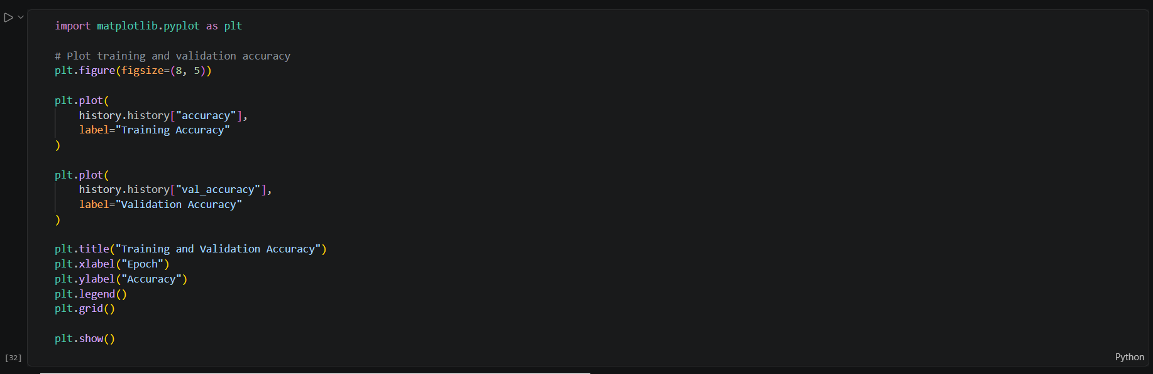

PART D: USING HUGGING FACE PRE-TRAINED MODELS
Perform the following tasks:
- Load a pre-trained vision model from Hugging Face.
- Perform image classification on sample images.
- Compare predictions with the transfer learning model.
- Document observations and upload the notebook to GitHub.

(CODE: CONATAINS STUDENT ROLL NOS
SCREENSHOT OF CODE
SCREENSHOT OF OUTPUT)

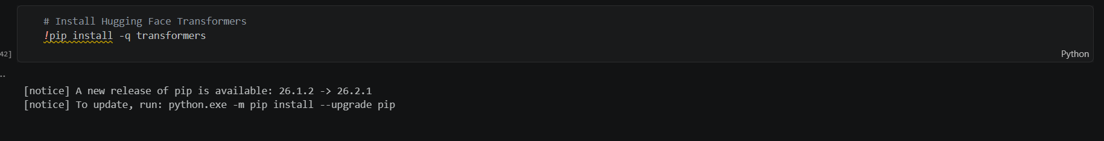

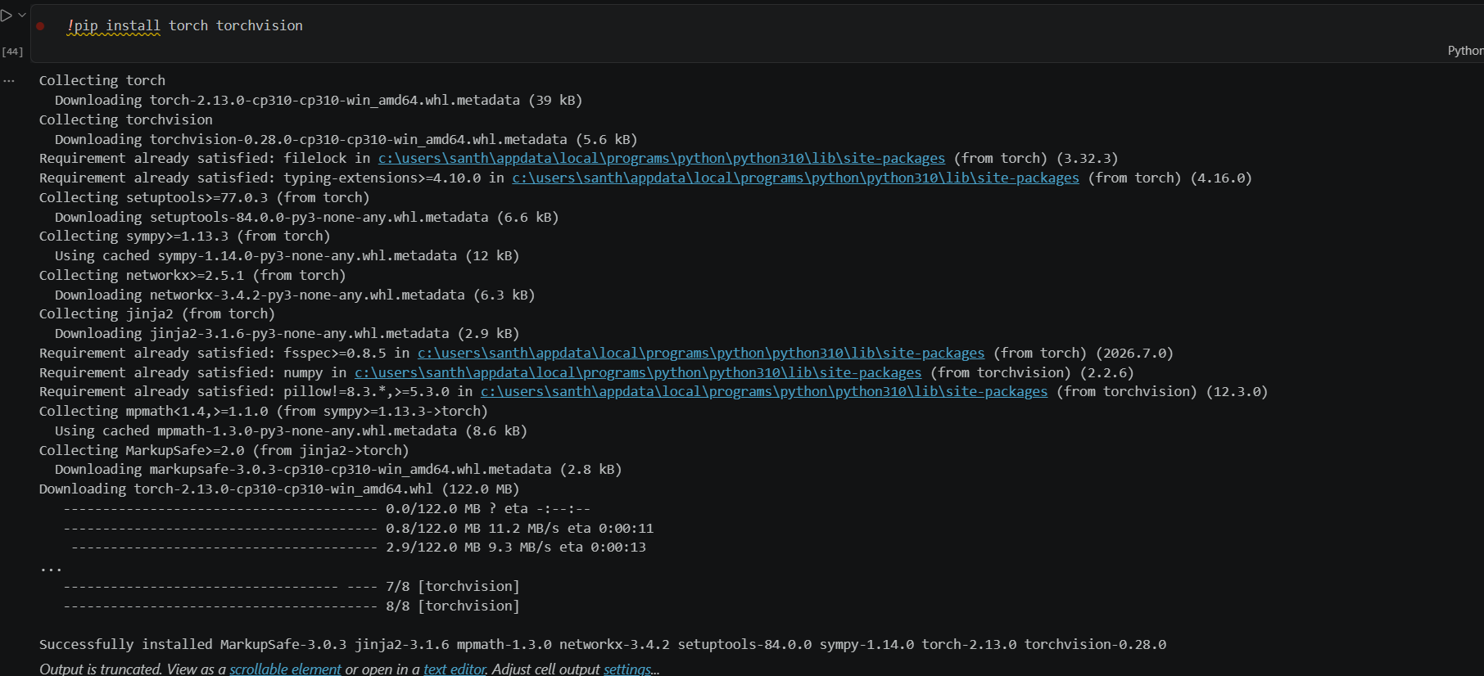

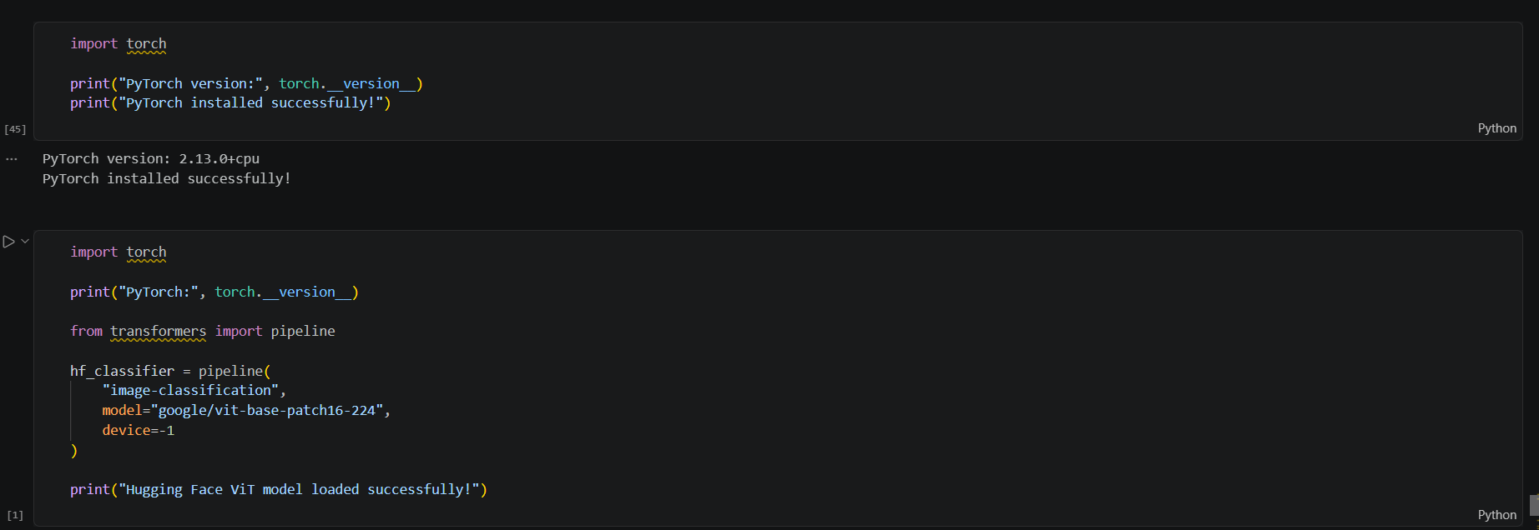

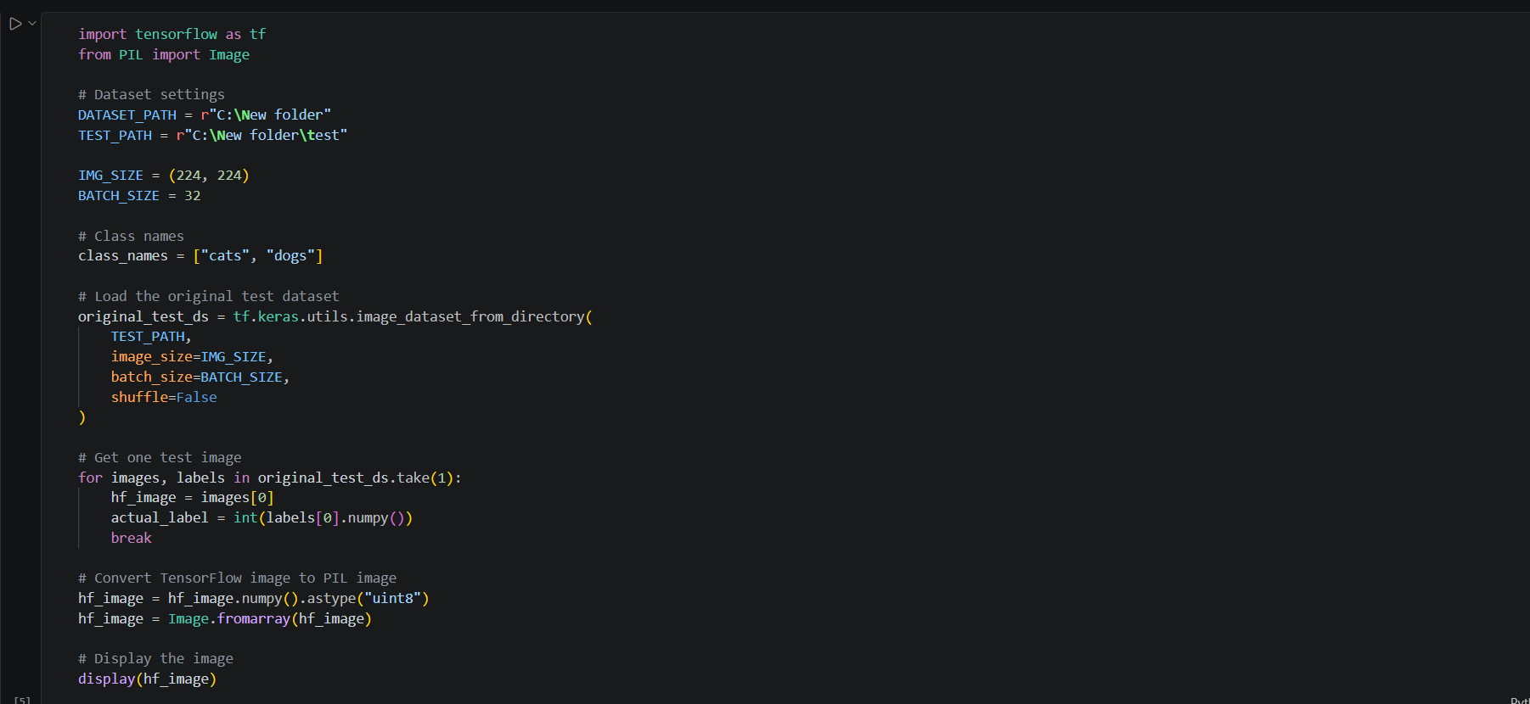

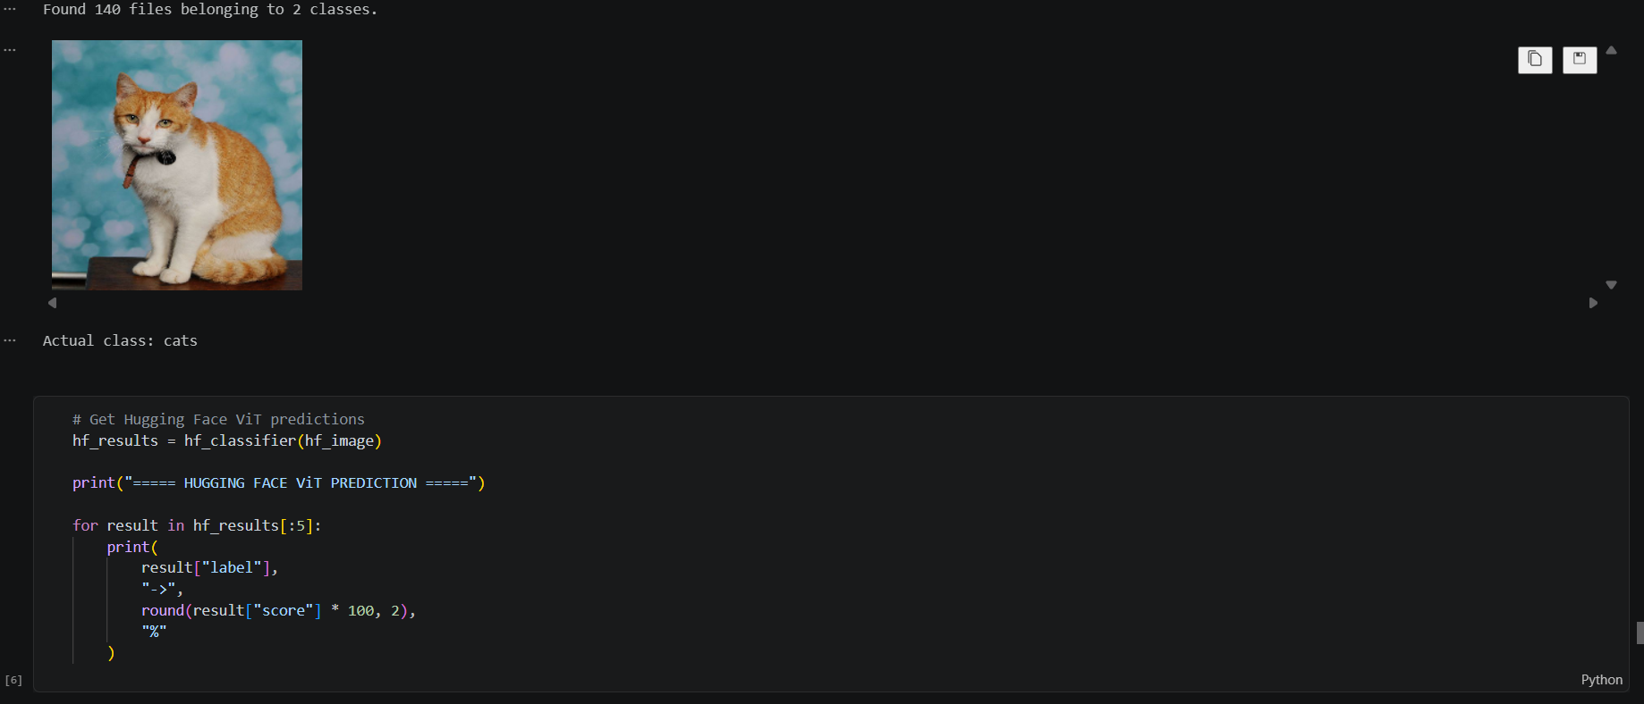

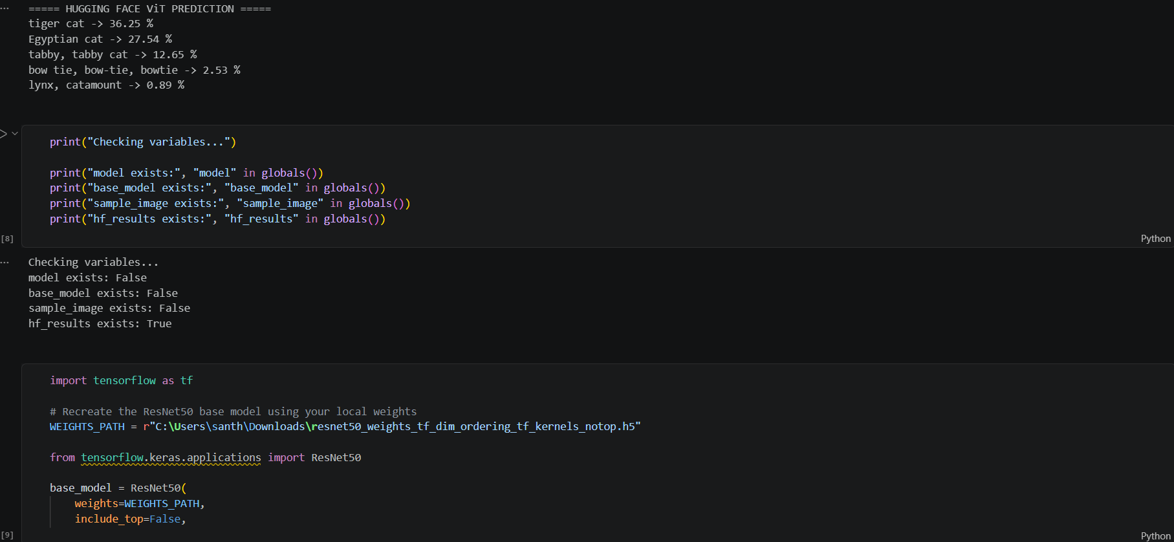

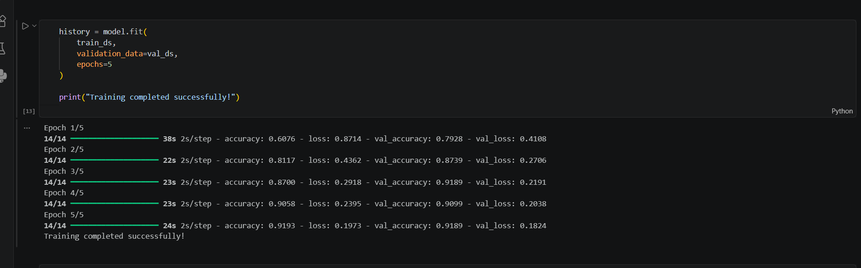

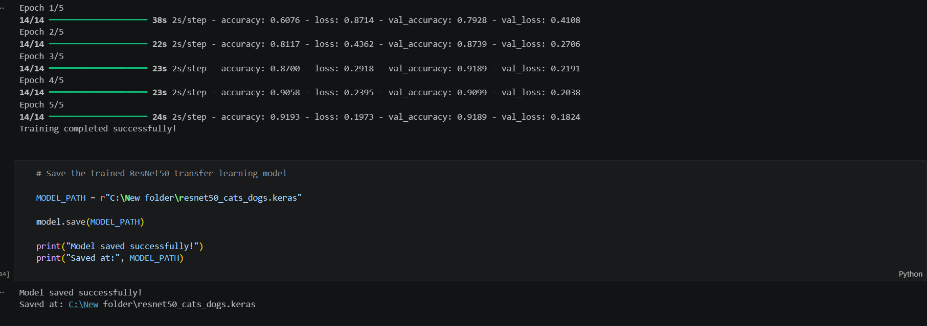

EXPECTED OUTCOME
Students will understand the advantages of transfer learning and gain practical experience in fine-tuning pre-trained vision models from TensorFlow/PyTorch and Hugging Face for image recognition tasks.

POST-LAB QUESTIONS (PROVIDE BRIEF ANSWERS TO THE FOLLOWING QUESTIONS)

ASSESSMENT
Description | Max Marks | Marks Awarded
Pre Lab Exercise | 5
In Lab Exercise | 10
Post Lab Exercise | 5
Viva | 10
Total | 30
Faculty Signature

